Yaveon Posting Rules
Posting Rules
The Yaveon 365 Lot Management app provides you with numerous posting rule groups. This allows you to create rules that allow or prevent postings based on different criteria. Furthermore, an item / lot on inventory can be explicitly excluded for availability during planning.
The action Import / Export allows the import and exports of rule groups as XML files. Additional filters can be set for the export of a single rule category or a special rule. The import is done via the generated XML file. Existing rules are overwritten by the imported rules.
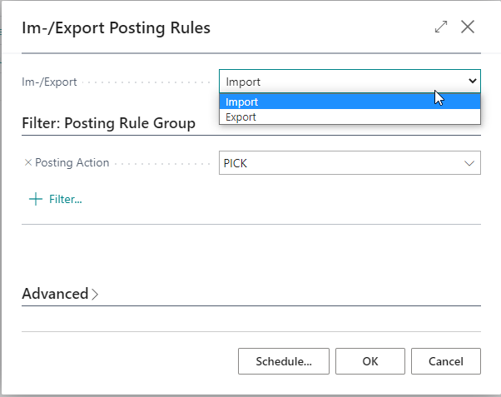

Follow the links to learn more about the different booking rules!
- Page 2 Assembly Consumption Rules
- Page 6 Item Availability
- Page 9 Pick/Provision/Replemishment Rules
- Page 12 Positive Adjustment Rules
- Page 17 Production Consumption Rules
- Page 20 Sales Shipment Rules
- Page 23 Transfer Shipment Rules

Assembly Consumption Rules
Posting rules allow you to control the criteria that allow or prevent your assembly consumption postings. You can set up your rules according to different conditions. The following conditions are available for you:
- Expired Goods
- Item
- Lot
- Manufactured Item
- Posted by User Group
- Posted by User ID
- Rem. Shelf Time (absolute) (Insert Condition Filter with date formula. For example <=12M)
- Rem. Shelf Time (%) (Condition Filter with operator <,>,= and number 0-100. For example <50)
- Serial No.
Note
When a lot is selected, its percentage remaining shelf life is determined as follows:
Shelf life = "Expiration date - Reference date" / Expiration date formula on item card.
Example: (01.06. - 01.01) / 12M = 6M / 12 M = 1/2 = 50%
The following date is used as reference date:
  - Assembly consumption: Due date
  - Item availability: Work Date
  - Picking: Due date
  - Pos. Adjustment, Purchase: Planned Receipt date
  - Pos. Adjustment, Journal: posting date
  - Pos. Adjustment, Transfer: Receipt date
  - Production consumption: due date
  - Sales Shipment: planned delivery date
  - Outgoing Transfer: Shipment date
It is possible to combine several conditions within a rule, that all must apply. In addition, the Priority field can be used to set the order in which your rules are checked. Rules are taken into account starting with the lowest priority, if the field Active is set.
Note
All conditions within a rule must be met for the rule to be applied. This also means, for example, that if the availability calculation is to refer to the status of lots and serial numbers, two rules must be created. One rule that refers to the lot and its status, and a second rule that is for the serial number data.
In addition, it is possible to define explicit exceptions. For this, the field Block Action must not be set for an active rule.
Setup example for an explicit exception rule:
- Priority=10: Assembly consumption postings of material with expired = Yes by User with User Group = yaveon are explicitly allowed by the rule and are not subject to any restriction. Thus, corresponding articles can be posted and users with a different user groups are subject to a restriction by the following rule with priority = 20.
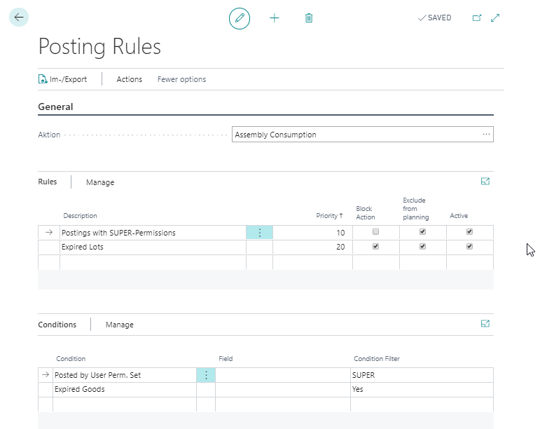
- Priority=20: Material usage posting for items whose expiration date is exceeded are not allowed and posting is prevented.
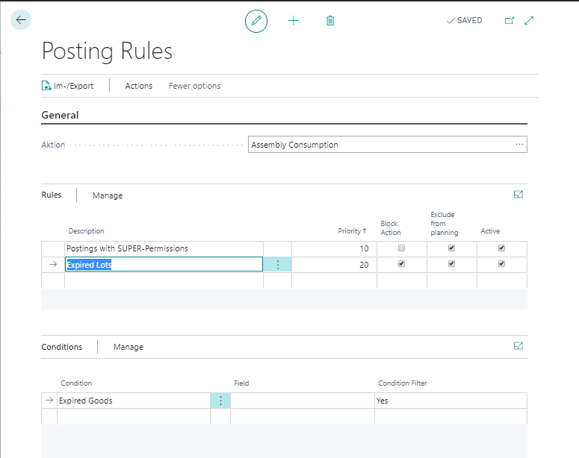
Exclude from planning
With this setting, an existing item or lot inventory can be excluded from the availability for planning. You can define whether or not an inventory is used to cover requirements, regardless of whether it can be posted in the respective process. This setting can be used for postings for the actions Production Consumption, Assembly Consumption, Sales Shipment and Transfer Shipment.
General example:
- Inventory with status "QC" may not be posted as production consumption.
- However, they should be available for MRP, since they are expected to be released soon and no new procurement proposal should be created.

Item Availability Rules
Posting rules for item availability allow you to define the criteria that control the document-independent availability or availability to cover safety stock and minimum stock of your inventory. Using different criteria, your items or lots in inventory will be shown as available or not available in general. You can set up your rules according to different conditions. The following conditions are available here.
- Expired Goods
- Item
- Lot
- Rem. Shelf Time (absolute) (Insert Condition Filter with date formula. For example <=12M)
- Rem. Shelf Time (%) (Condition Filter with operator <,>,= and number 0-100. For example <50)
- Serial No.
Note
When a lot is selected, its percentage remaining shelf life is determined as follows:
Shelf life = "Expiration date - Reference date" / Expiration date formula on item card.
Example: (01.06. - 01.01) / 12M = 6M / 12 M = 1/2 = 50%
The following date is used as reference date:
- Assembly consumption: Due date
- Item availability: Work Date
- Picking: Due date
- Pos. Adjustment, Purchase: Planned Receipt date
- Pos. Adjustment, Journal: posting date
- Pos. Adjustment, Transfer: Receipt date
- Production consumption: due date
- Sales Shipment: planned delivery date
- Outgoing Transfer: Shipment date
Availability rules with action type item availability are used for the document-independent availability calculation. This affects the following places in the system:
- Field Available inventory item (base) in the Inventory Summary
- Fields Availability balance or Inventory in the pages Item availability by period / location
- Available inventory in the Sales Line details
By setting the Exclude from planning indicator, lots or serial numbers that meet the defined criteria can be excluded to cover safety stock and minimum stock. A distinction in this regard is currently not possible.
If the Expired Goods condition is used in a rule, the inventory summary must be updated daily. This update is performed using the task Inventory Summary - Update availability. To see the effect of newly created item availability rules immediately, this task must be processed manually.
Note
For the availability calculation when creating different documents, e.g. Picking, please set up explicit posting rules. If you set up your posting rule group item availability analogous to your posting rule groups Picking or Sales Delivery, you can, for example, check the actual availability beforehand via your Inventory Summary. 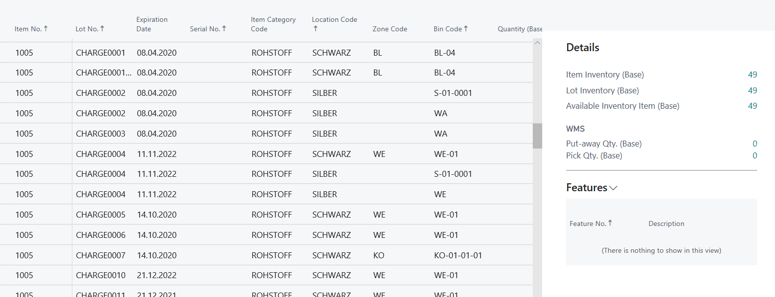
It is possible to combine several conditions within a rule, all of which must apply. In addition, the Priority field can be used to set the order in which your rules are checked. Rules are taken into account starting with the lowest priority, if the field Active is set.
Note
All conditions within a rule must be met for the rule to be applied. This also means, for example, that if the availability calculation is to refer to the status of lots and serial numbers, two rules must be created. One rule that refers to the lot and its status, and a second rule that is for the serial number data.
In addition, it is possible to define explicit exceptions. For this, the field Block Action must not be set for an active rule.
Setup example for an explicit exception rule:
- Priority=10: The availability for items with the storage group = PACKMAT is explicitly not restricted if the remaining shelf life of the lot is less than 12 months. This may be the case if the packaging material is not critical to your production or sales process.
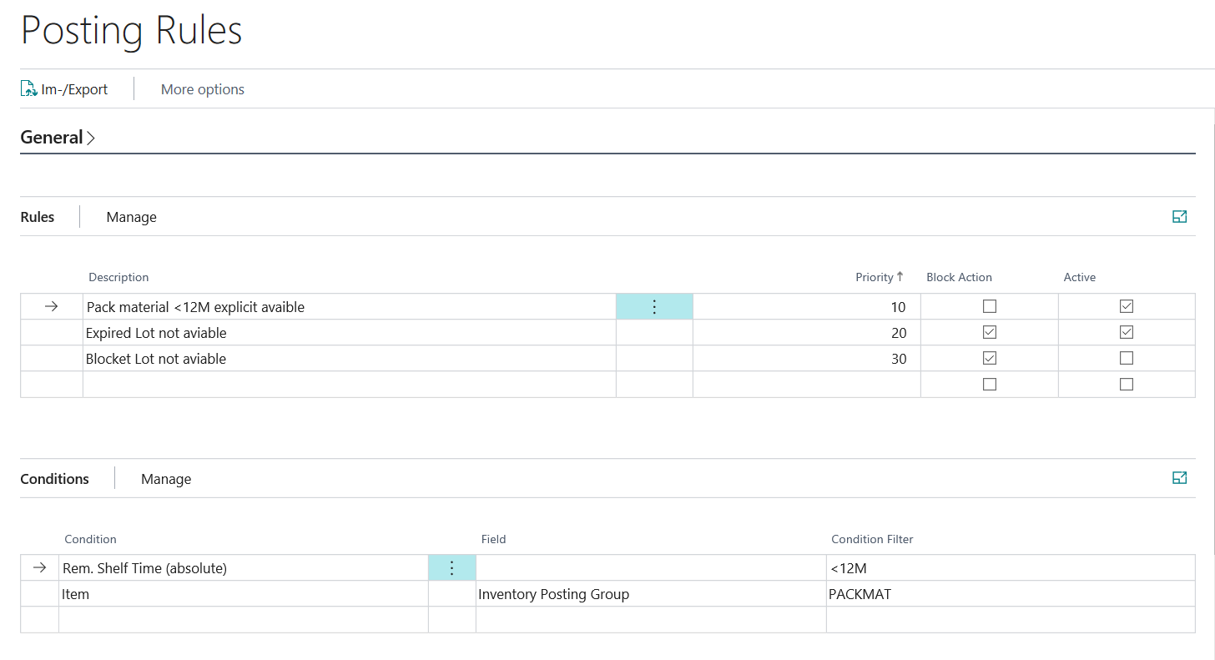
- Priority=20: If a lot = Expired this is no longer included in the general availability calculation.
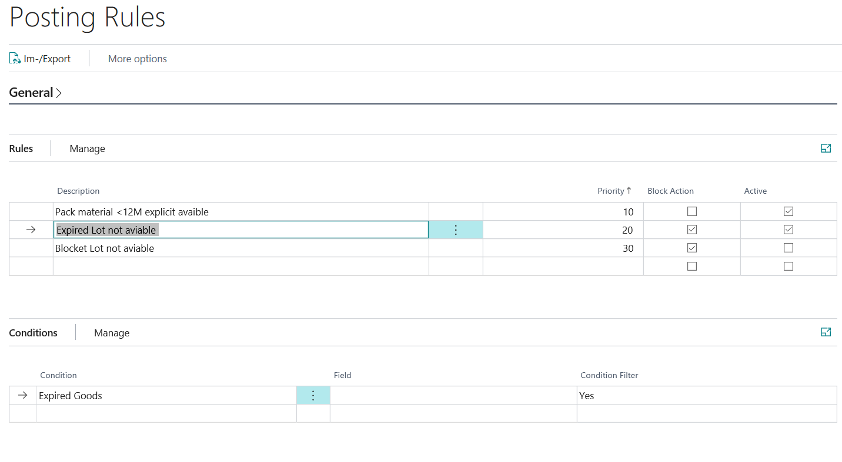
Note
In the YAVEON feature management, it is possible to activate the Performance-Optimized Rules Check for Availability Calculation feature. This feature optimizes performance within Business Central when availability rules are checked, e.g. during the creation of sales lines. The optimization is particularly effective for companies in which there is a large number of lots for an item. The only tradeoff is that during some transactions the availability of an item is buffered for a maximum of a minute to reduce the amount of calculations during a single transaction. The feature will be extended with further performance improvements in the future.
Pick/Provision/Replenishment Rules
Posting rules for Pick/Provision/Replenishment allow you to control which item, lots or serial numbers should be available for Pick, Provision or Replenishment. You can define the criteria according to which a Pick-, Provision- or Replenishment line creation or registration is allowed or prevented. The following conditions are available here:
- Expired Goods
- Item
- Lot
- Source Document
- Posted by User Group
- Posted by User ID
- Rem. Shelf Time (absolute) (Insert Condition Filter with date formula. For example <=12M)
- Rem. Shelf Time (%) (Condition Filter with operator <,>,= and number 0-100. For example <50)
- Serial No.
Note
When a lot is selected, its percentage remaining shelf life is determined as follows:
Shelf life = "Expiration date - Reference date" / Expiration date formula on item card.
Example: (01.06. - 01.01) / 12M = 6M / 12 M = 1/2 = 50%
The following date is used as reference date:
- Assembly consumption: Due date
- Item availability: Work Date
- Picking: Due date
- Pos. Adjustment, Purchase: Planned Receipt date
- Pos. Adjustment, Journal: posting date
- Pos. Adjustment, Transfer: Receipt date
- Production consumption: due date
- Sales Shipment: planned delivery date
- Outgoing Transfer: Shipment date
When selecting the condition Source Document the following options will be visible:
Source Document | Additional Options
Sales Order | Sell-to Country Code  Sell-to Customer
Production Consumption | Manufactured Item
Assembly Consumption | Manufactured Item
Outbound Transfer | Transfer To Location Code
It is possible to combine several conditions within a rule, that all must apply. In addition, the Priority field can be used to set the order in which your rules are checked. Rules are taken into account starting with the lowest priority, if the field Active is set.
Note
All conditions within a rule must be met for the rule to be applied. This also means, for example, that if the availability calculation is to refer to the status of lots and serial numbers, two rules must be created. One rule that refers to the lot and its status, and a second rule that is for the serial number data.
Additionally explicit exceptions can be defined using the Block Action field. To allow pick postings do not set this flag.
Setup example for an explicit exception rule
- Priority=20: For lots with the status GESPERRT and with the inventory posting group ROHMAT the picking is prevented. This is the general rule.
- Exception Priority=10: The posting of a picking with blocked lots for the article PB_30001 (with the inventory posting group ROHMAT, Master Data Setup) is explicitly permitted.
Definition of exception: 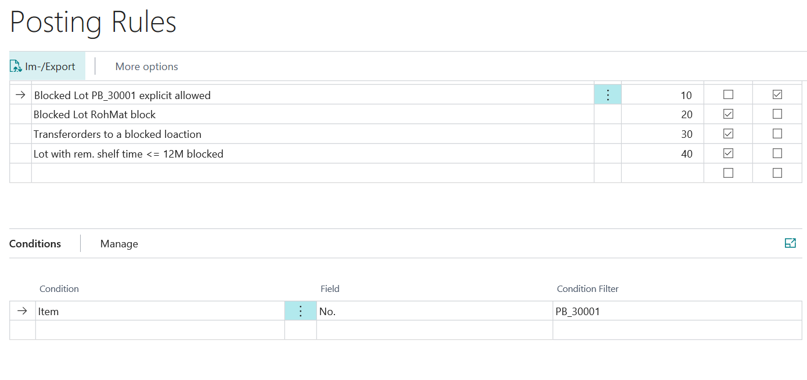
Definition of general rule: 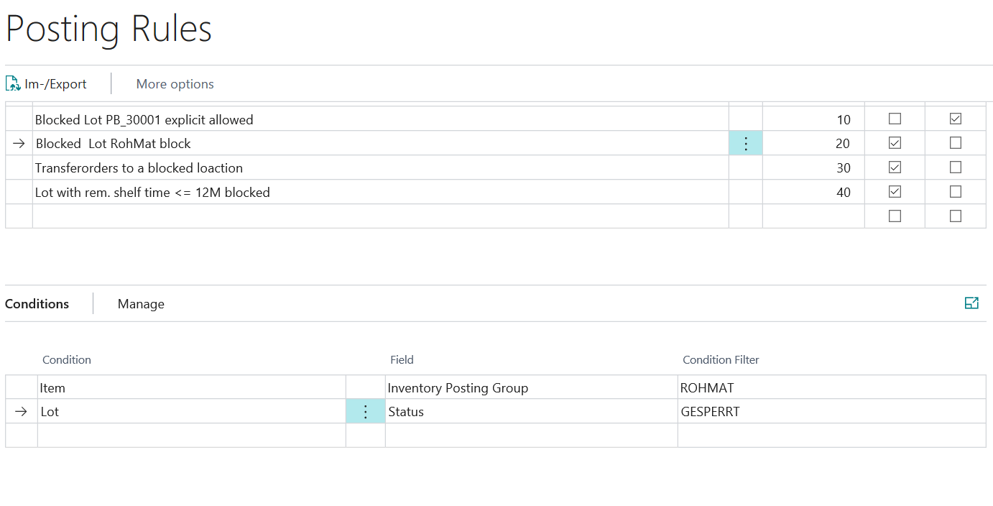
Positive Adjustment Rules
Posting rules allow you to control the criteria according to which your positive adjustment postings are allowed or prevented.
The positive adjustment posting can be performed
- via Worksheet (even Reclassification Worksheet or Whse. Reclassification Worksheet)
- via Purchase Order (or follow-on documents such as posting the warehouse receipt or creating and registering the put-away) or
- through Physical Inventory
- in a Warehouse Movement that has been created via Replenishment Wksh. or
- Inventory Movements
You can set up your rules according to different conditions. The following conditions are available here:
- Location Code
- Zone Code
- Bin Code
- Expired Goods
- Item
- Lot
- Posted by User Group
- Posted by User ID
- Rem. Shelf Time (absolute) (Insert Condition Filter with date formula. For example <=12M)
- Rem. Shelf Time (%) (Condition Filter with operator <,>,= and number 0-100. For example <50)
- Serial No.
Note
From version BC22 upwards, user groups are replaced by Yaveon User Groups.
Note
When a lot is selected, its percentage remaining shelf life is determined as follows:
Shelf life = "Expiration date - Reference date" / Expiration date formula on item card.
Example: (01.06. - 01.01) / 12M = 6M / 12 M = 1/2 = 50%
The following date is used as reference date:
- Assembly consumption: Due date
- Item availability: Work Date
- Picking: Due date
- Pos. Adjustment, Purchase: Planned Receipt date
- Pos. Adjustment, Journal: posting date
- Pos. Adjustment, Transfer: Receipt date
- Production consumption: due date
- Sales Shipment: planned delivery date
- Outgoing Transfer: Shipment date
It is possible to combine several conditions within a rule, that all must apply. In addition, the Priority field can be used to set the order in which your rules are checked. Rules are taken into account starting with the lowest priority, if the field Active is set.
Note
All conditions within a rule must be met for the rule to be applied. This also means, for example, that if the availability calculation is to refer to the status of lots and serial numbers, two rules must be created. One rule that refers to the lot and its status, and a second rule that is for the serial number data.
In addition, it is possible to define explicit exceptions. For this, the field Block Action must not be set for an active rule.
Setup example for an explicit exception rule:
- Priority=10: The positive adjustment posting of the article with the number = PB_30001 and the product posting group = ROHMAT on the storage location = Blau is explicitly permitted by the rule and is not subject to any restrictions.
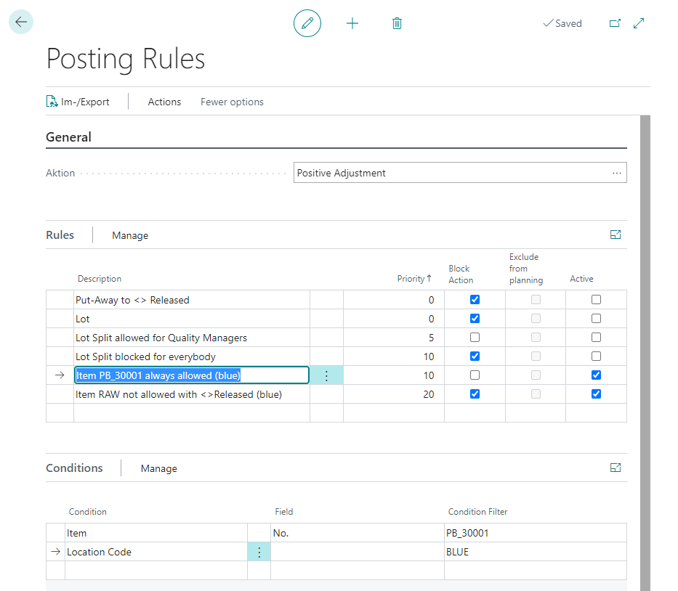
- Priority=20: The positive adjustment postings of articles with the product posting group = ROHMAT and a lot status <> Approved is not allowed for the storage location = BLAU.
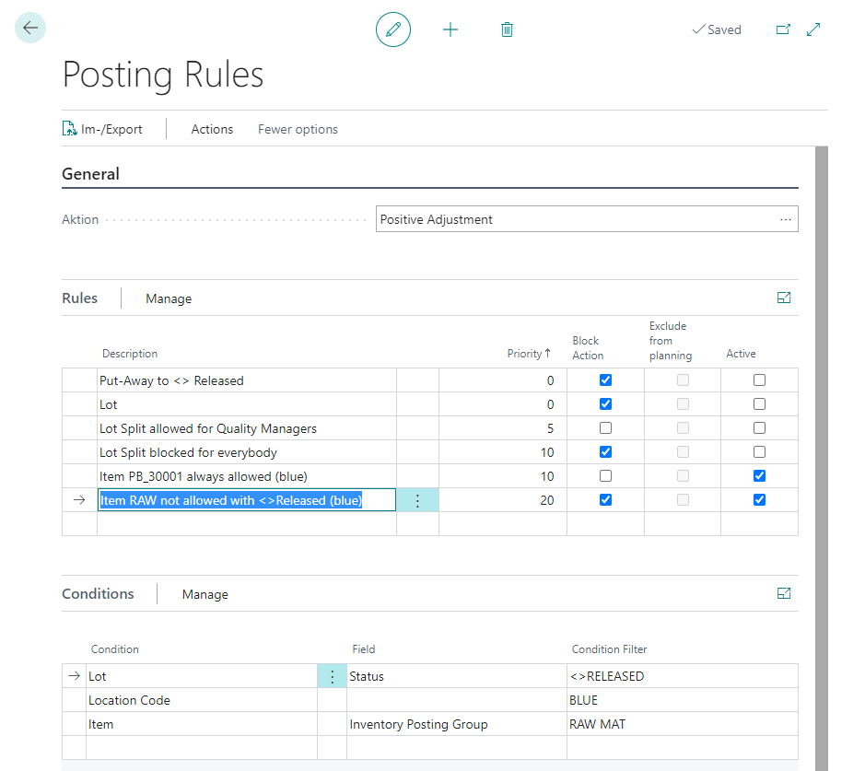
Setup Example for Positive Adjustment of "Ethanol"
In the following example, it is defined that the item E1200001, which is ethanol, may only be stored in a specific, designated bin RL-02-05-02. In addition, an incoming goods bin is permitted to enable delivery. If a storage bin other than those defined here is specified in a warehouse receipt or putaway, an error message appears.
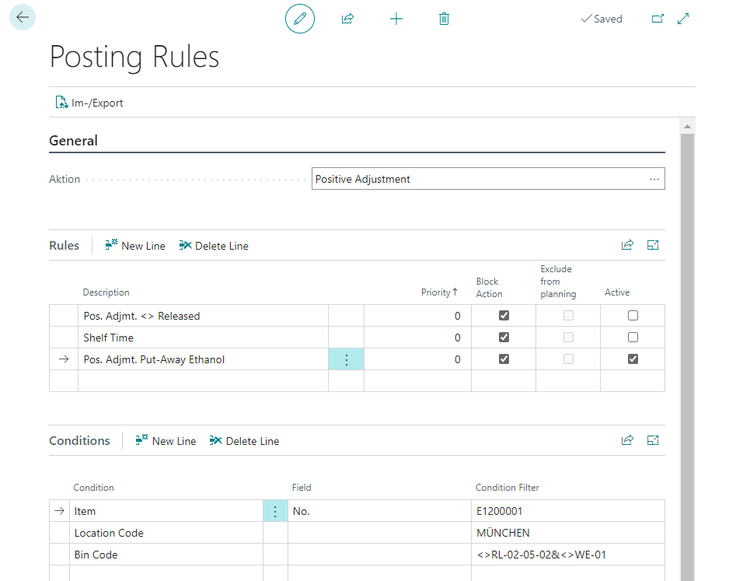
Production Consumption Rules
Posting rules allow you to control the criteria according to which your production consumption postings are allowed or prevented. You can set up your rules according to different conditions. The following conditions are available here.
- Expired Goods
- Item
- Lot
- Finished Item
- Posted by User Group
- Posted by User ID
- Rem. Shelf Time (absolute) (Insert Condition Filter with date formula. For example <=12M)
- Rem. Shelf Time (%) (Condition Filter with operator <,>,= and number 0-100. For example <50)
- Serial No.
Note
When a lot is selected, its percentage remaining shelf life is determined as follows:
Shelf life = "Expiration date - Reference date" / Expiration date formula on item card.
Example: (01.06. - 01.01) / 12M = 6M / 12 M = 1/2 = 50%
The following date is used as reference date:
  - Assembly consumption: Due date
  - Item availability: Work Date
  - Picking: Due date
  - Pos. Adjustment, Purchase: Planned Receipt date
  - Pos. Adjustment, Journal: posting date
  - Pos. Adjustment, Transfer: Receipt date
  - Production consumption: due date
  - Sales Shipment: planned delivery date
  - Outgoing Transfer: Shipment date
It is possible to combine several conditions within a rule, that all must apply. In addition, the Priority field can be used to set the order in which your rules are checked. Rules are taken into account starting with the lowest priority, if the field Active is set.
Note
All conditions within a rule must be met for the rule to be applied. This also means, for example, that if the availability calculation is to refer to the status of lots and serial numbers, two rules must be created. One rule that refers to the lot and its status, and a second rule that is for the serial number data.
In addition, it is possible to define explicit exceptions. For this, the field Block Action must not be set for an active rule.
Setup example for an explicit exception rule:
- Priority=10: Consumption postings of articles with the master data device product posting group = Sonstige and a lot status = FREIGEGEBEN are explicitly permitted by the rule and are not subject to any restrictions. Thus, corresponding item can be posted and only items with a different product posting group are subject to the residual durability test by the second rule.
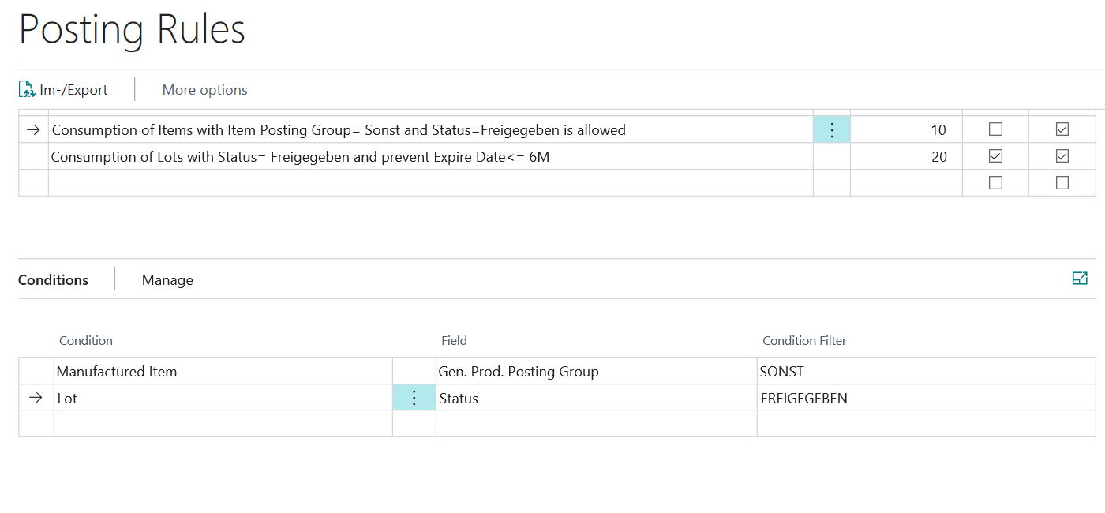
- Priority=20: Consumption postings of items with a lot status = FREIGEGEBEN and a remaining shelf life <= 6 months are not allowed and a posting is prevented.
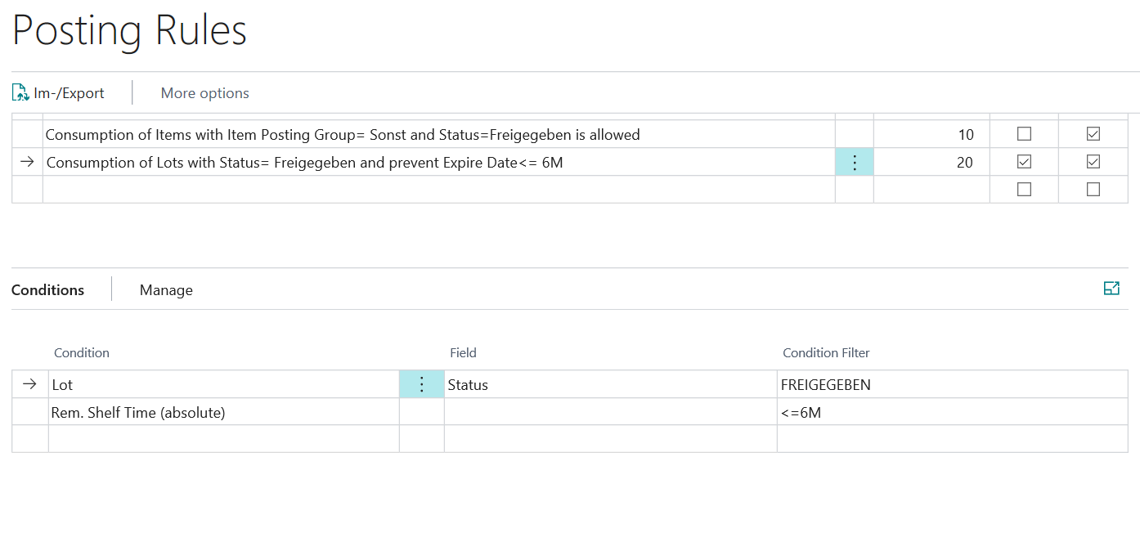
Exclude from planning
With this setting, an existing item or lot inventory can be excluded from the availability for planning. You can define whether or not an inventory is used to cover requirements, regardless of whether it can be posted in the respective process. This setting can be used for postings for the actions Production Consumption, Assembly Consumption, Sales Shipment and Transfer Shipment.
General example:
- Inventory with status "QC" may not be posted as production consumption.
- However, they should be available for MRP, since they are expected to be released soon and no new procurement proposal should be created.
Sales Shipment Rules
Posting rules allow you to control the criteria according to which postings to your sales deliveries are permitted or prevented. You can set up your rules according to different conditions. The following conditions are available here:
- Sell to Customer
- Sell to Country
- Expired Goods
- Item
- Lot
- Finished Item
- Posted by User Group
- Posted by User ID
- Rem. Shelf Time (absolute) (Insert Condition Filter with date formula. For example <=12M)
- Rem. Shelf Time (%) (Condition Filter with operator <,>,= and number 0-100. For example <50)
- Serial No.
Note
When a lot is selected, its percentage remaining shelf life is determined as follows:
Shelf life = "Expiration date - Reference date" / Expiration date formula on item card.
Example: (01.06. - 01.01) / 12M = 6M / 12 M = 1/2 = 50%
The following date is used as reference date:
  - Assembly consumption: Due date
  - Item availability: Work Date
  - Picking: Due date
  - Pos. Adjustment, Purchase: Planned Receipt date
  - Pos. Adjustment, Journal: posting date
  - Pos. Adjustment, Transfer: Receipt date
  - Production consumption: due date
  - Sales Shipment: planned delivery date
  - Outgoing Transfer: Shipment date
It is possible to combine several conditions within a rule, that all must apply. In addition, the Priority field can be used to set the order in which your rules are checked. Rules are taken into account starting with the lowest priority, if the field Active is set.
Note
All conditions within a rule must be met for the rule to be applied. This also means, for example, that if the availability calculation is to refer to the status of lots and serial numbers, two rules must be created. One rule that refers to the lot and its status, and a second rule that is for the serial number data.
In addition, it is possible to define explicit exceptions. For this, the field Block Action must not be set for an active rule.
Setup example for an explicit exception rule:
- Priority=10: Posting a sales delivery to the customer = 100 for articles with a lot status = GESPERRT is explicitly permitted by the rule and is not subject to any restrictions.
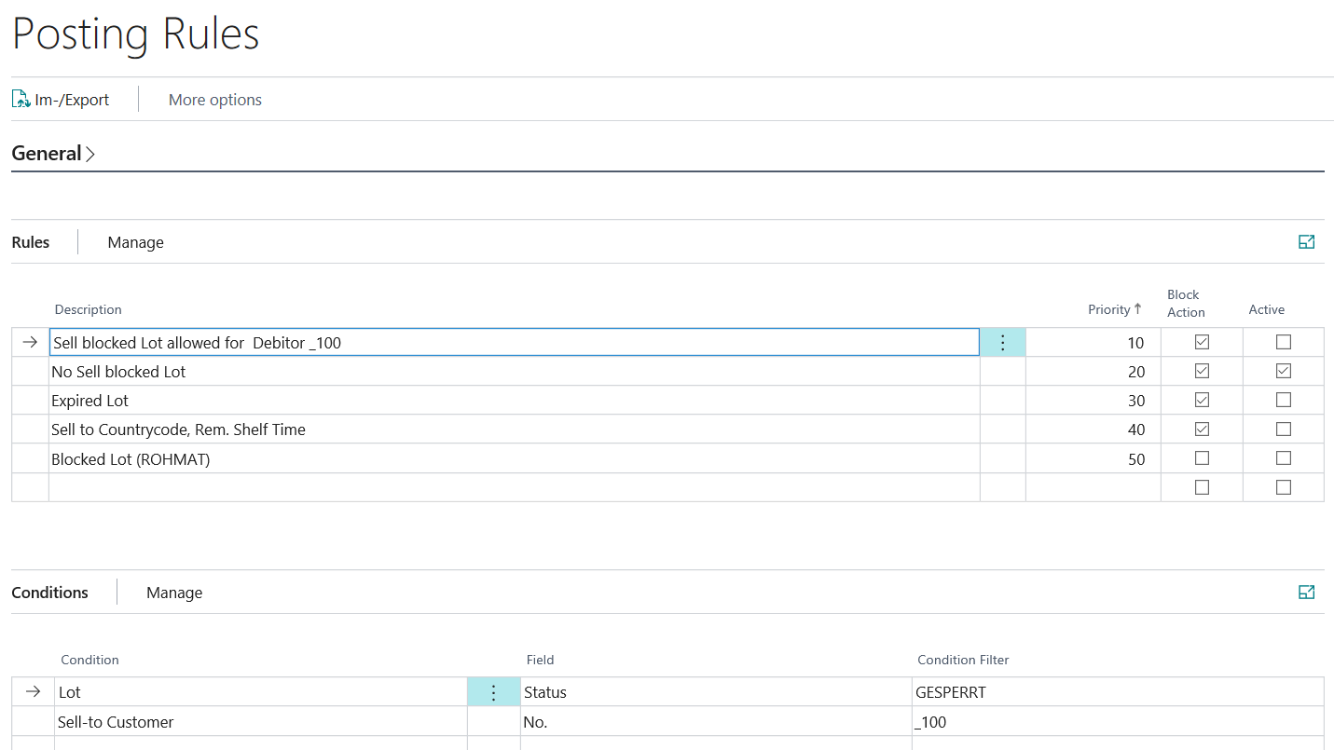
- Priority=20: Posting a sales delivery of items with the lot status = GESPERRT is not allowed.
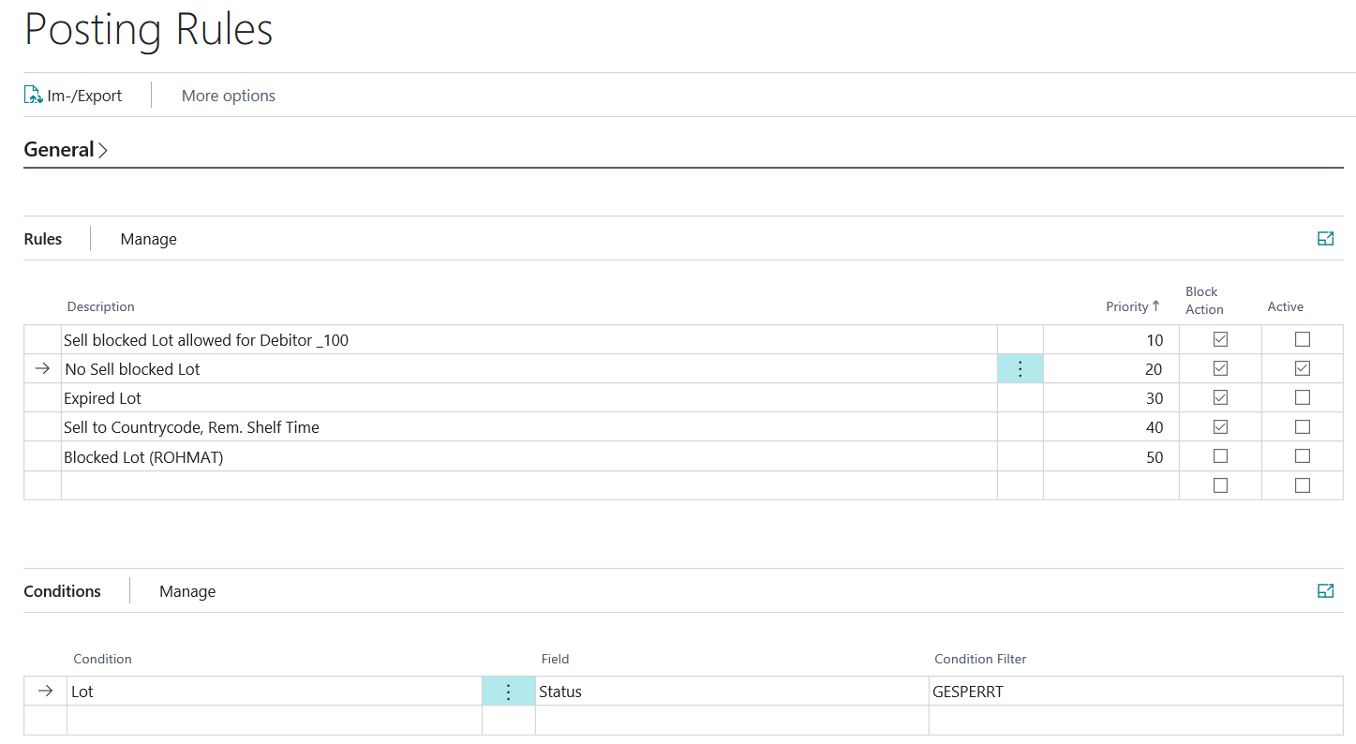
Exclude from planning
With this setting, an existing item or lot inventory can be excluded from the availability for planning. You can define whether or not an inventory is used to cover requirements, regardless of whether it can be posted in the respective process. This setting can be used for postings for the actions Production Consumption, Assembly Consumption, Sales Shipment and Transfer Shipment.
General example:
- Inventory with status "QC" may not be posted as production consumption.
- However, they should be available for MRP, since they are expected to be released soon and no new procurement proposal should be created.
Transfer Shipment Rules
Posting rules allow you to control the criteria according to which postings of your stock transfer exits are allowed or prevented. You can set up your rules according to different conditions. The following conditions are available here.
- Expired Goods
- Item
- Lot
- Posted by User Group
- Posted by User ID
- Rem. Shelf Time (absolute) (Insert Condition Filter with date formula. For example <=12M)
- Rem. Shelf Time (%) (Condition Filter with operator <,>,= and number 0-100. For example <50)
- Transfer to Location Code
- Serial No.
Note
When a lot is selected, its percentage remaining shelf life is determined as follows:
Shelf life = "Expiration date - Reference date" / Expiration date formula on item card.
Example: (01.06. - 01.01) / 12M = 6M / 12 M = 1/2 = 50%
The following date is used as reference date:
  - Assembly consumption: Due date
  - Item availability: Work Date
  - Picking: Due date
  - Pos. Adjustment, Purchase: Planned Receipt date
  - Pos. Adjustment, Journal: posting date
  - Pos. Adjustment, Transfer: Receipt date
  - Production consumption: due date
  - Sales Shipment: planned delivery date
  - Outgoing Transfer: Shipment date
It is possible to combine several conditions within a rule, that all must apply. In addition, the Priority field can be used to set the order in which your rules are checked. Rules are taken into account starting with the lowest priority, if the field Active is set.
Note
All conditions within a rule must be met for the rule to be applied. This also means, for example, that if the availability calculation is to refer to the status of lots and serial numbers, two rules must be created. One rule that refers to the lot and its status, and a second rule that is for the serial number data.
In addition, it is possible to define explicit exceptions. For this, the field Lock must not be set for an active rule.
Setup example for an explicit exception rule:
- Priority=10: The posting location SPERR for items with the inventory posting group = ROHMAT and the lot status = QUARANTÄNE is explicitly permitted by the rule and is not subject to any restrictions.
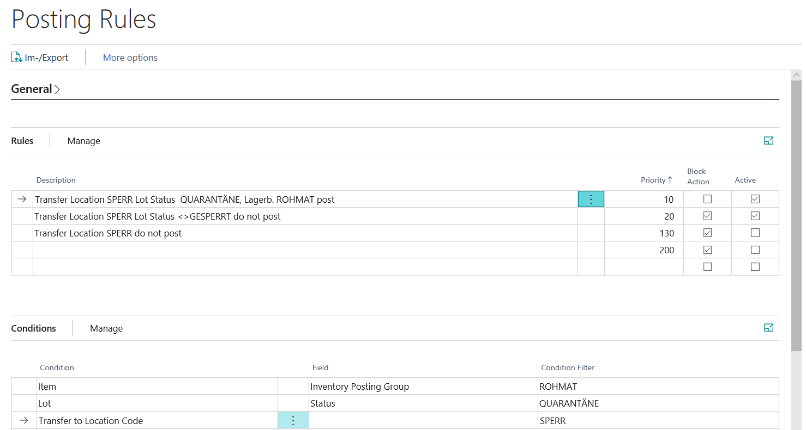
- Priority=20: The entry posting to the storage location SPERR is not allowed for articles with the lot status<>GESPERRT.
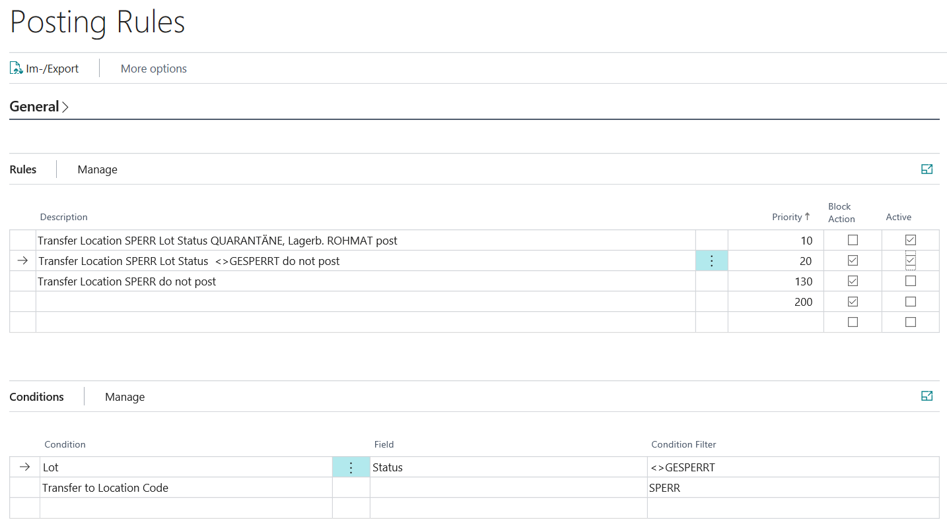
Exclude from planning
With this setting, an existing item or lot inventory can be excluded from the availability for planning. You can define whether or not an inventory is used to cover requirements, regardless of whether it can be posted in the respective process. This setting can be used for postings for the actions Production Consumption, Assembly Consumption, Sales Shipment and Transfer Shipment.
General example:
- Inventory with status "QC" may not be posted as production consumption.
- However, they should be available for MRP, since they are expected to be released soon and no new procurement proposal should be created.

