SOP : How to Bookmark page in Business Central.
- Option 1 :
  - From the Home page hit the search
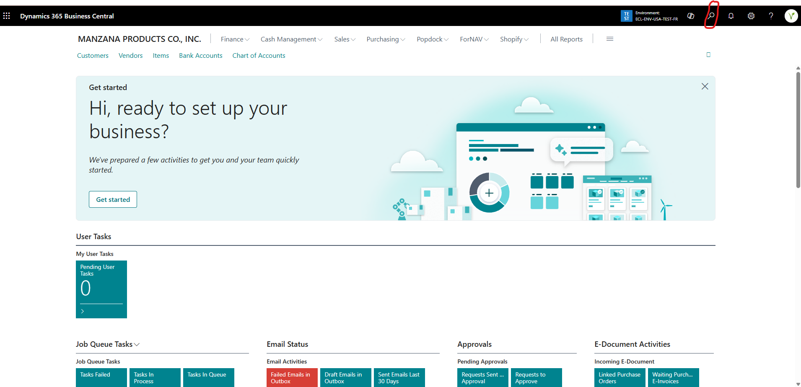
  - Type the menu you want to bookmark
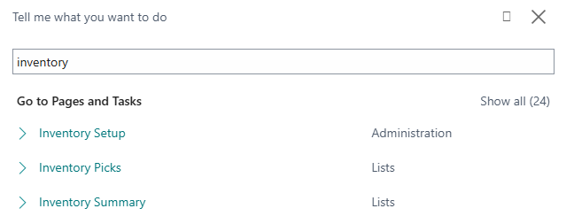
  - Place your cursor on the menu you want to bookmark, it turns “green” and the logo appears. Hit the to bookmark the menu on the Home page
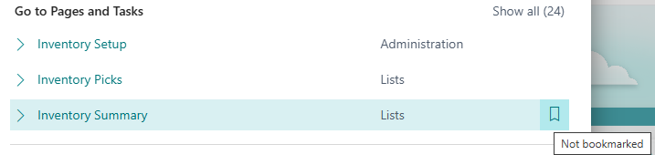

- Option 2
  - Open the Menu you want to bookmark and hit the on the top on the page
