Post Item Tracking Lines for Consumption Journals

Consuming leftover apple bins.
For this process you will need to have the following screens open:
ITEM LEDGER ENTRIES
CONSUMPTION JOURNAL
APPLES IN THE YARD - Export to excel for easy viewing.
INVENTORY SUMMARY
- In Item ledger entries enter:
Search apple PO. This will give you the MR # of where the apples were used.
Take the MR number and use it on the consumption journal.
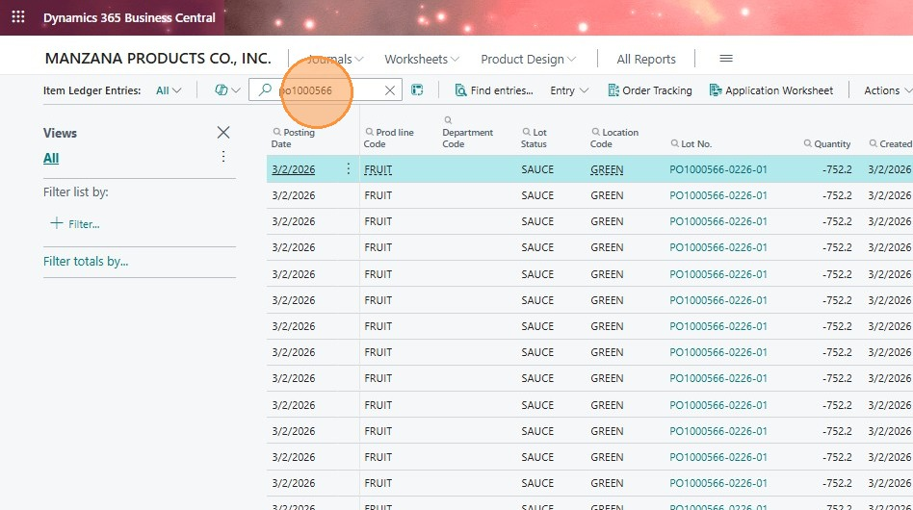
- On the consumption journal enter the following:
POSTING DATE: PLEASE MAKE SURE ITS THE DATE APPLES WERE USED
MR # on the Order No.
Item no. (apple item)
Bin code (double check inventory summary)
Quantity (from inventory summary)
Load carrier No. (from inventory summary)
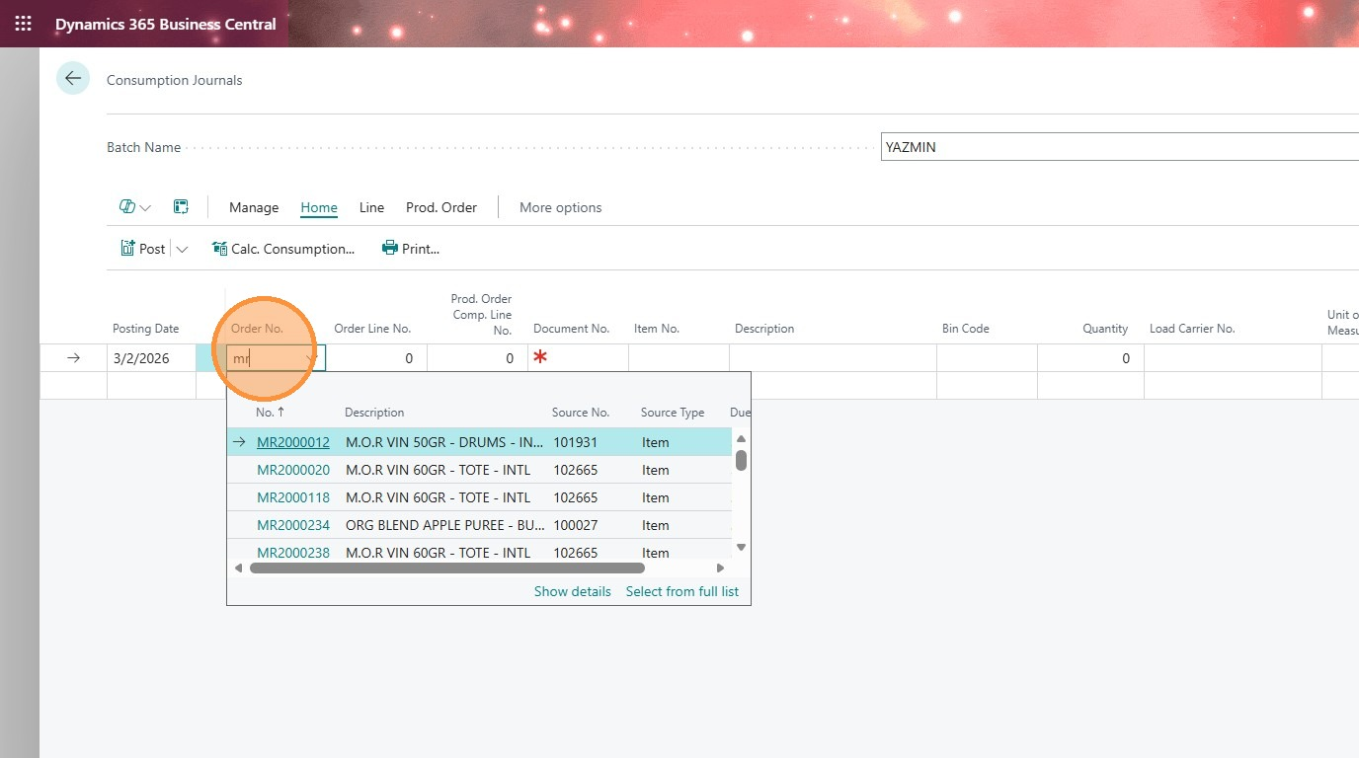
- Go into
Line
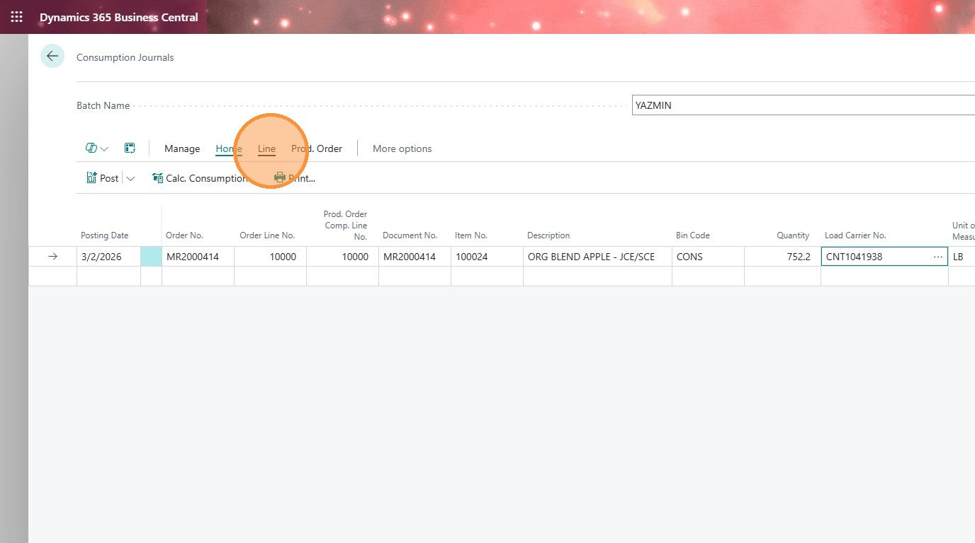
- Item tracking
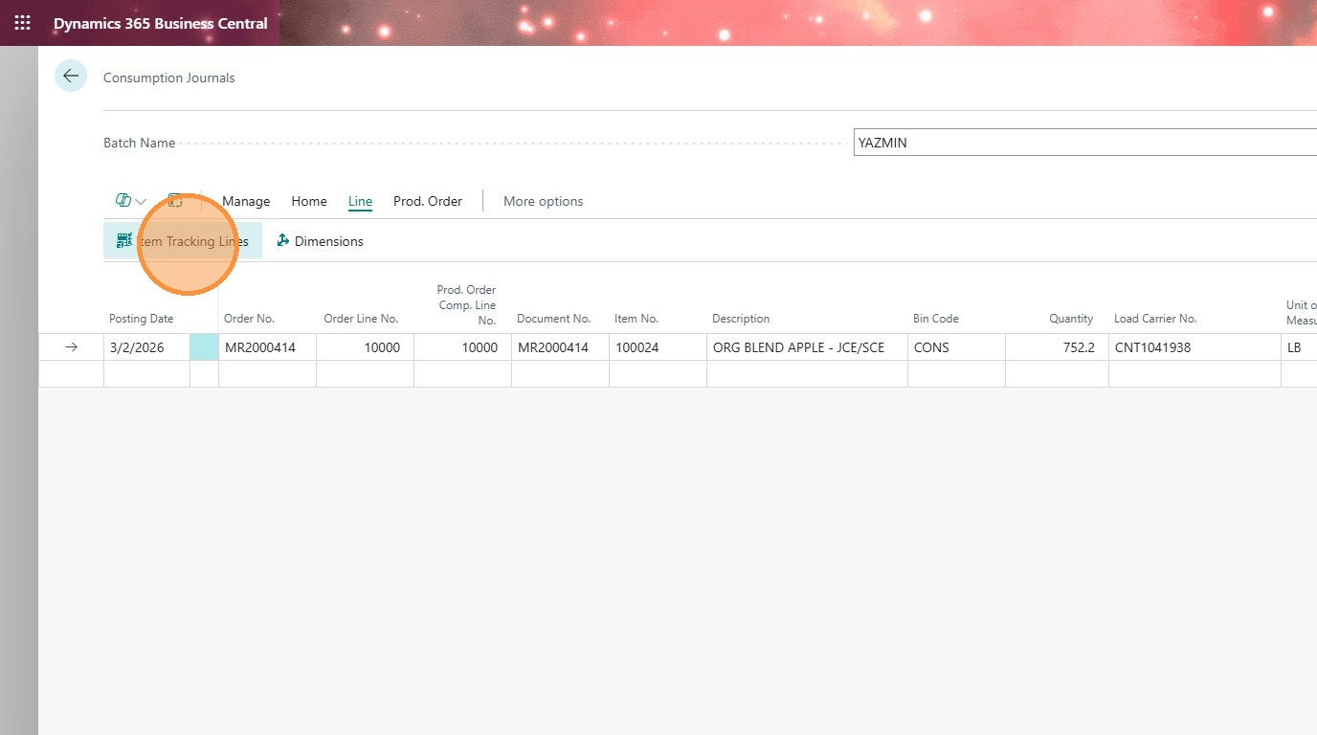
- Click the 3 dots to get a list of lot numbers.
Select the correct lot number to consume
Qty will autopopulate
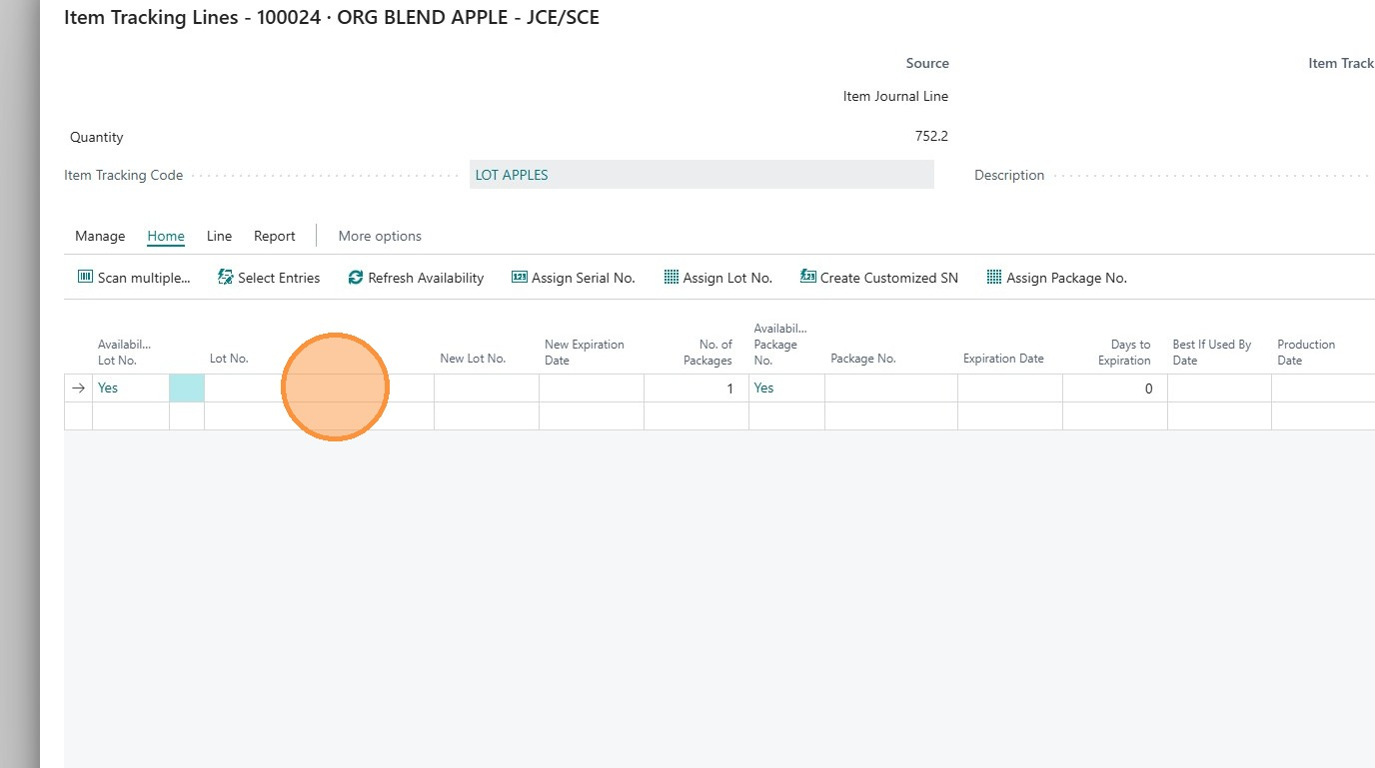
- Click "Close" after lot number has been selected and qty is autopopulated.
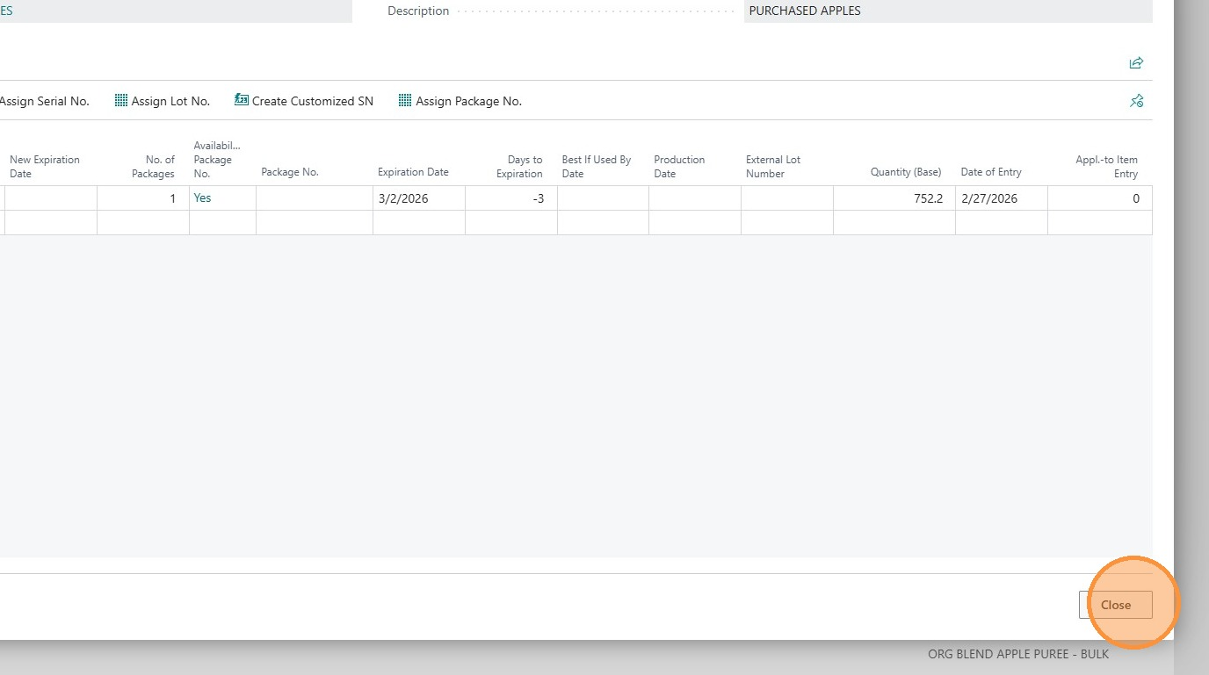
- Click "Home"
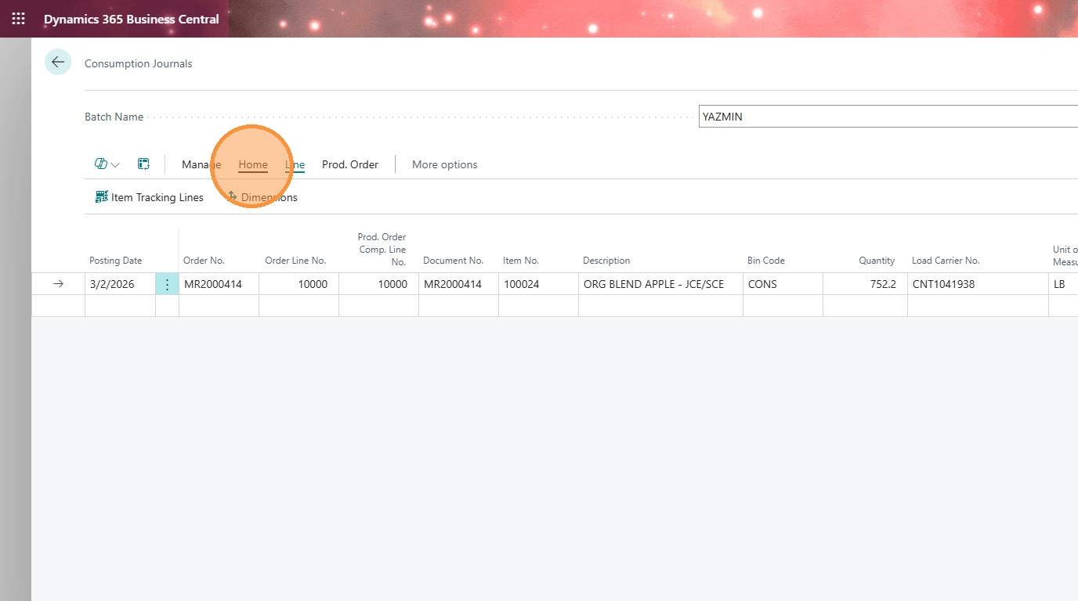
- Before posting PLEASE check posting date (This should be the same day apples were consumed)
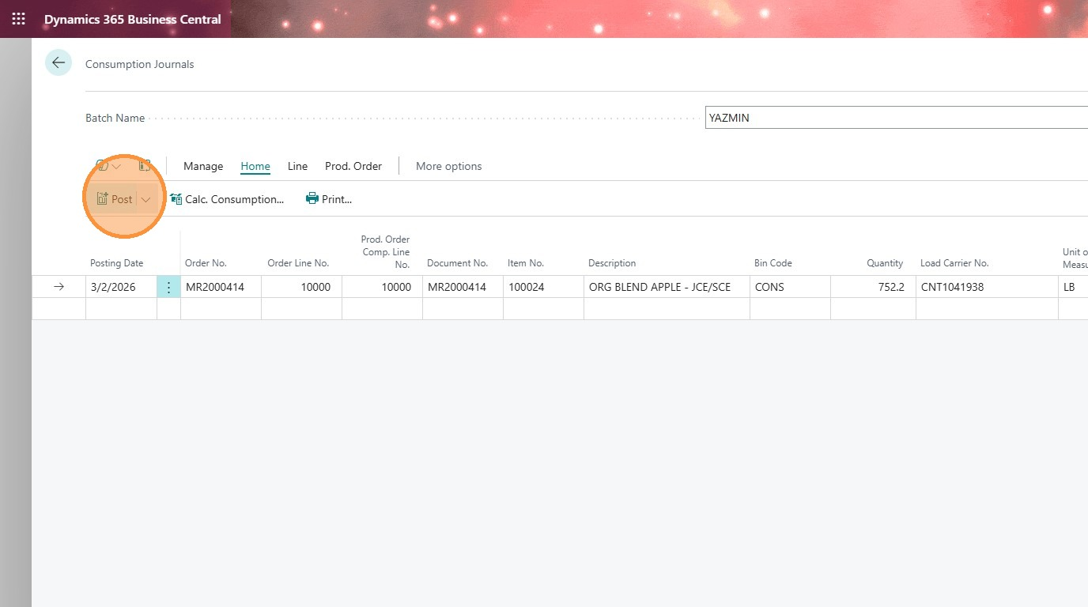
- Click "Yes"
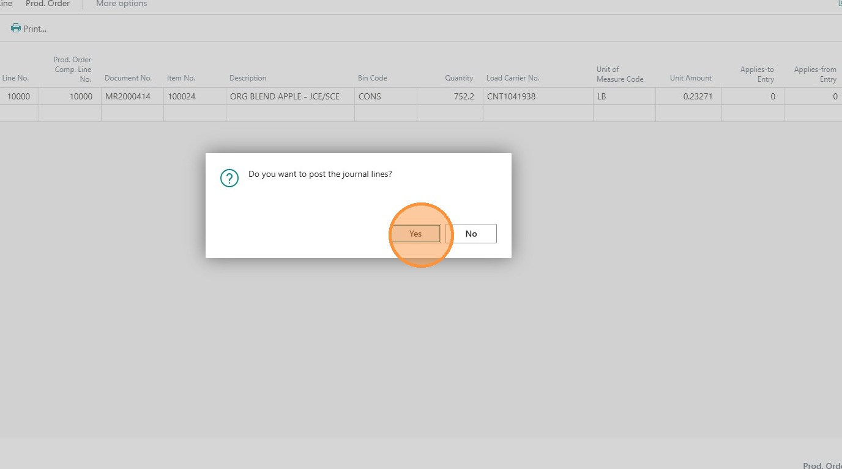
- Click "OK"
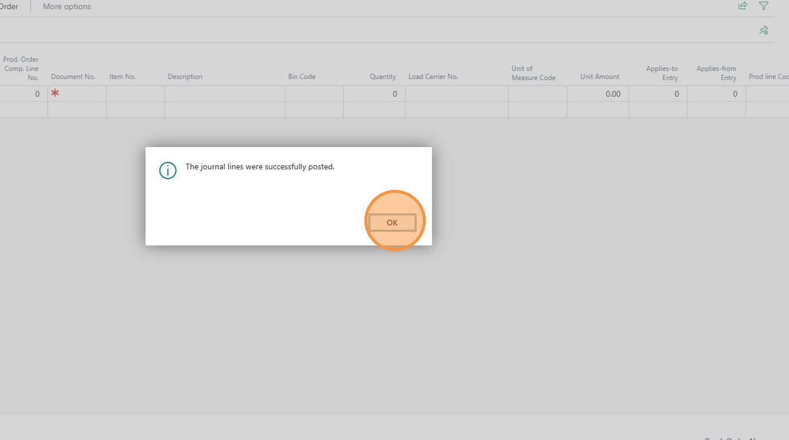
- All done and now repeat for any miss consumptions.

